**1.QuickSort program:**

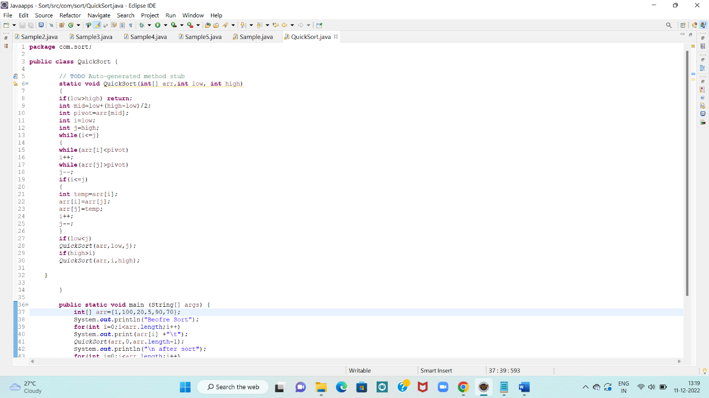

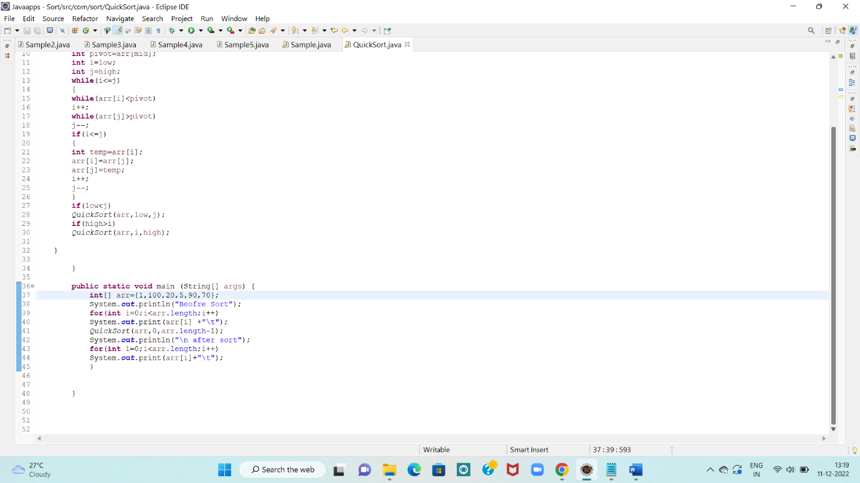

OUTPUT:

Before Sort

1 100 20 5 90 70

after sort

1 5 20 70 90 100

**2.BUBBLE SORT:**

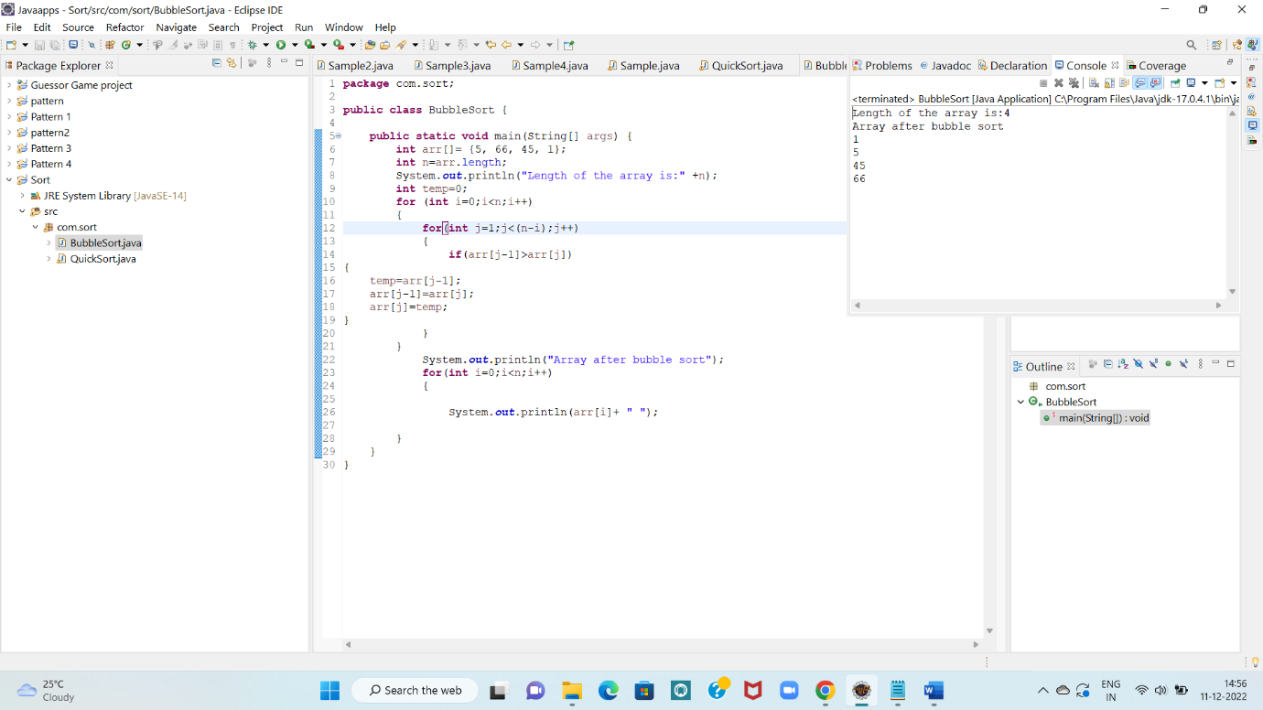

**3.Merge sort:**

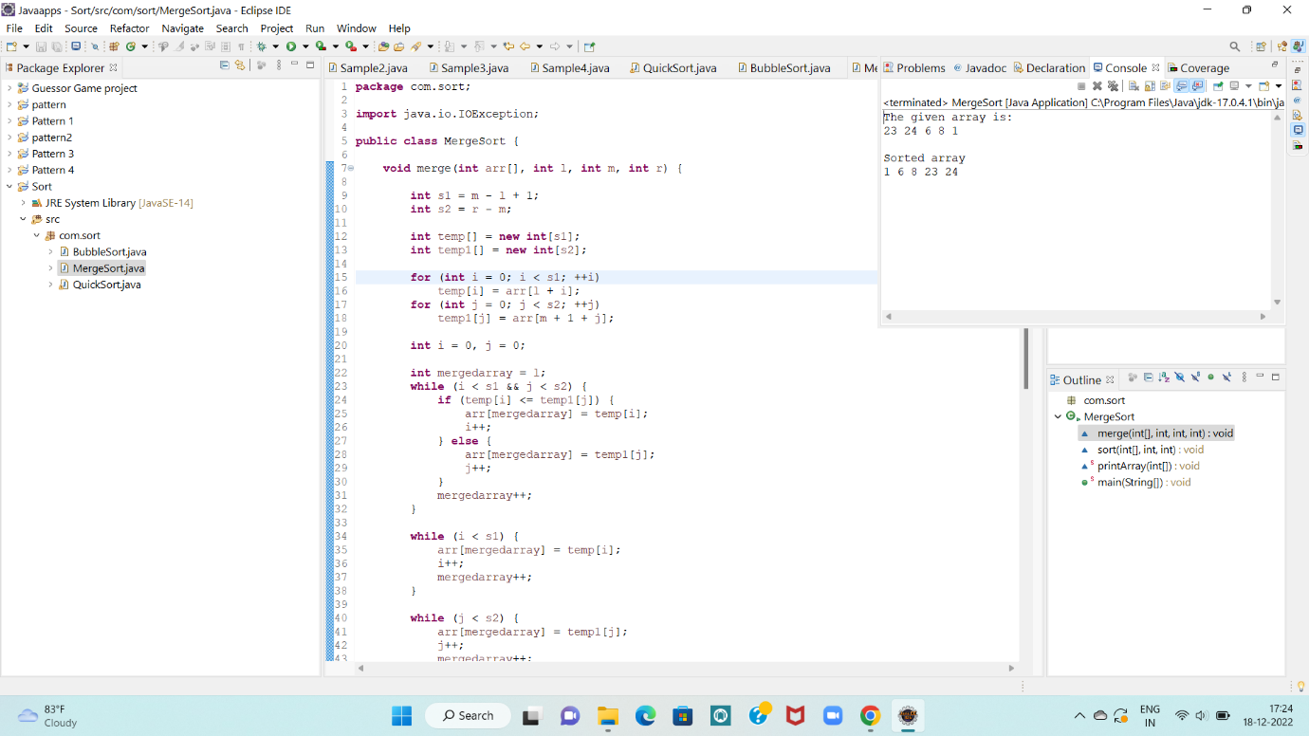

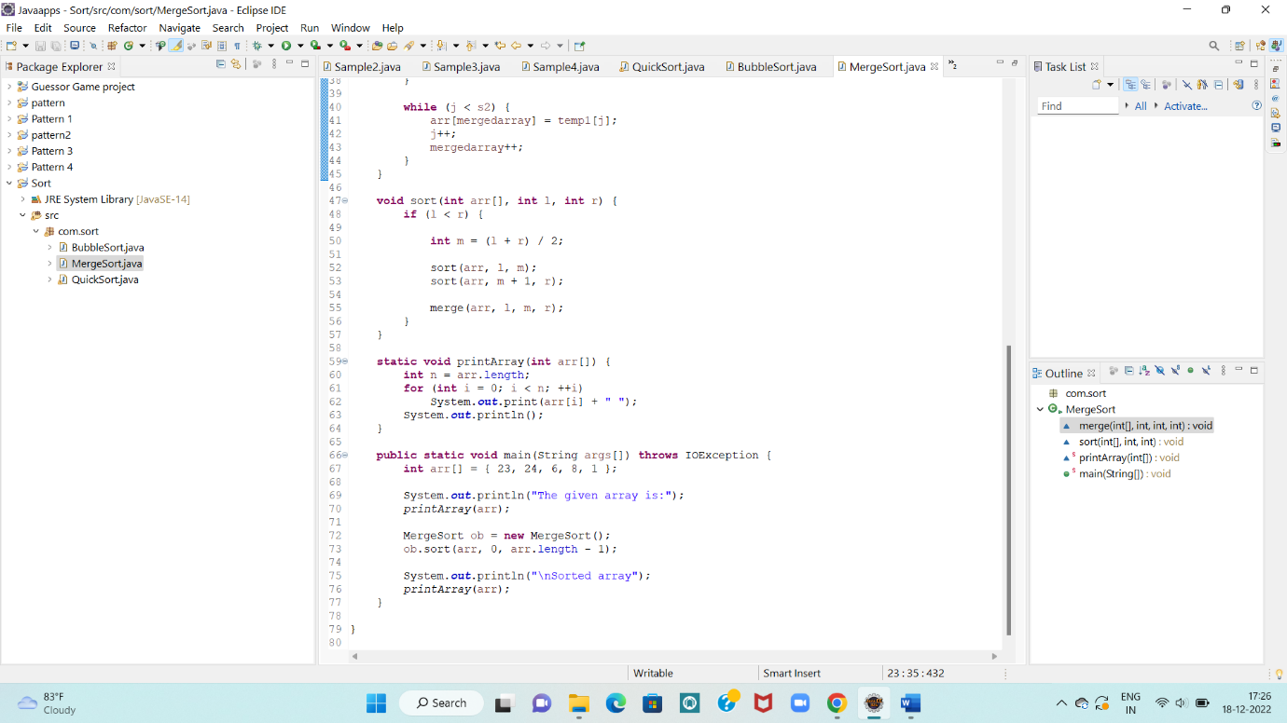

**4.Selection Sort:**

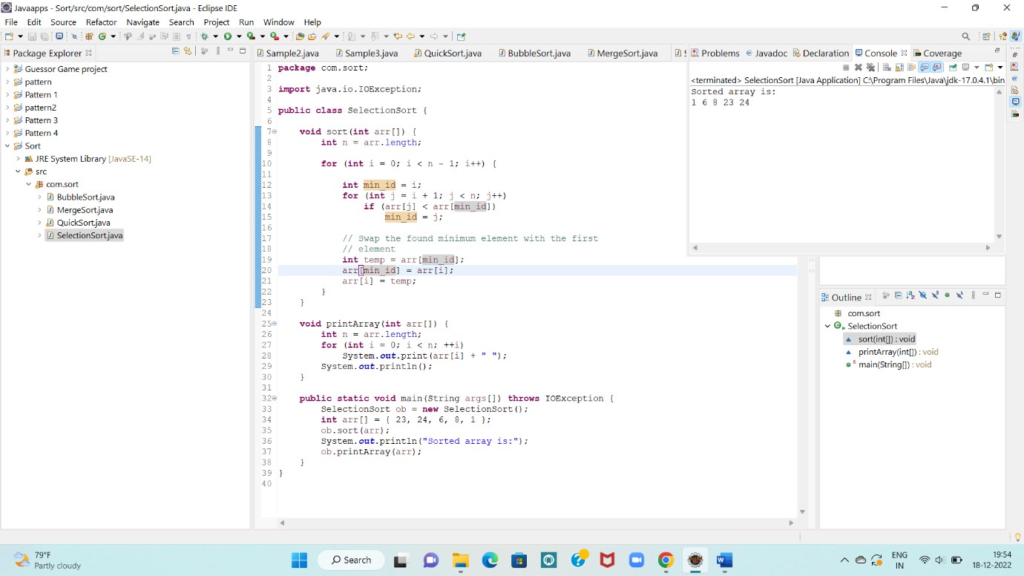

**5.WAP to check whether an array is a subset of another array.**

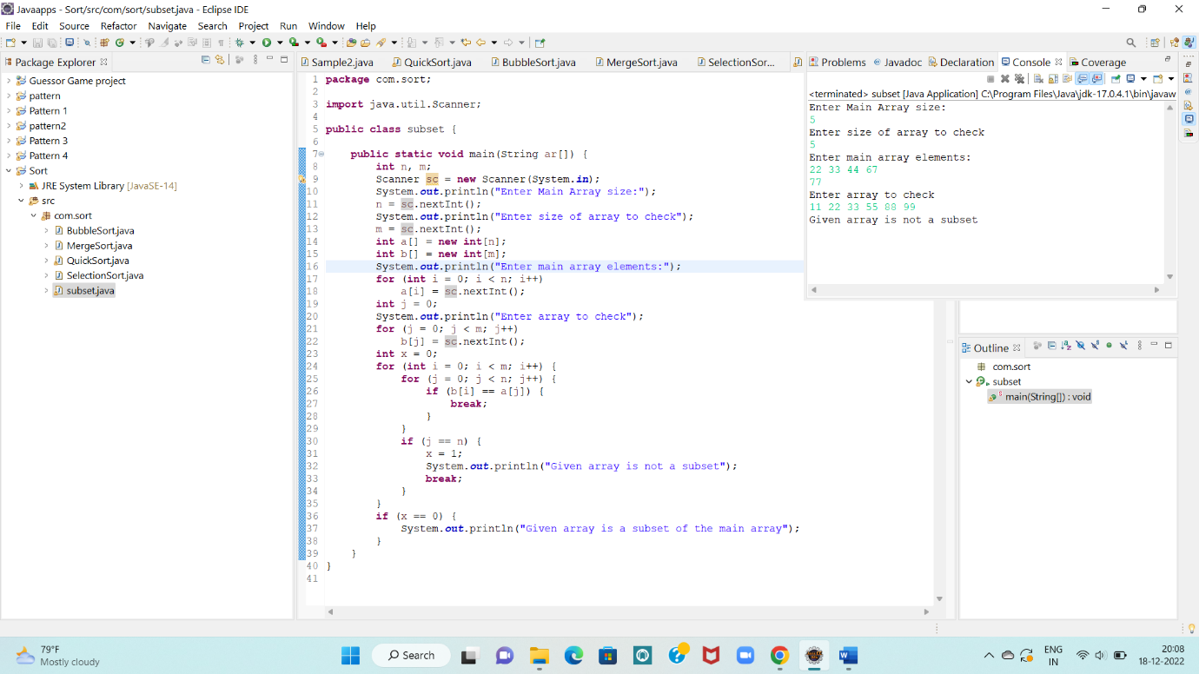

**6.WAP to find the duplicates present in an array.**

